Table of Contents

# Step 1

Under the Home tab, expand the Styles window from the Ribbon.

Alternatively press ***Alt + Ctrl + Shift + S***

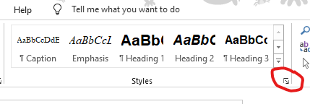

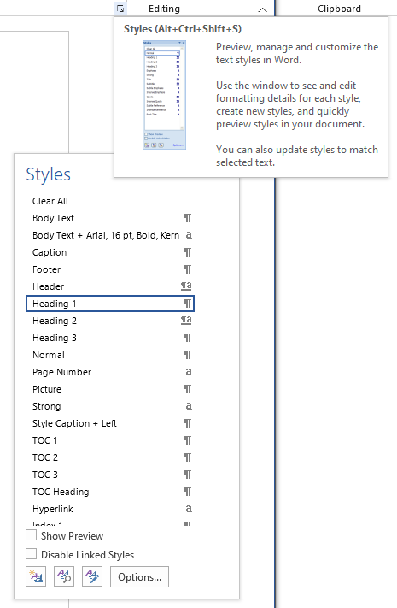

# Step 2

Highlight the first header for the first chapter of the report.

Apply the Style Heading 1.